ASSIGNMENT 1

**AIM**:

Create a circuit with Piezo alarm,PIR sensor,Temperature sensor with below functionalities:

# 1.Alarm should sound in one manner if temp is above 60 C

# 2.Alarm should sound with another frequency if motion is detected in PIR sensor

**CODE:**

void setup()

{

Serial.begin(9600);

pinMode(4,INPUT);

pinMode(11,OUTPUT);

}

void lp()

{

int motion=digitalRead(4);

Serial.print("Position is :");

Serial.println(motion);

if(motion==1){

tone(11,30);

delay(1500);

}

else{

noTone(11);

delay(1000);

}

double data=analogRead(A1);

double n=data/1024;

double volt=n*5;

double off=volt-0.5;

int temp=off*100;

Serial.print("Temperature is:");

Serial.println(temp);

if(temp>=60){

tone(11,700);

delay(500);

}

else{

noTone(11);

}}

**Output**:

Circuit Diagram:

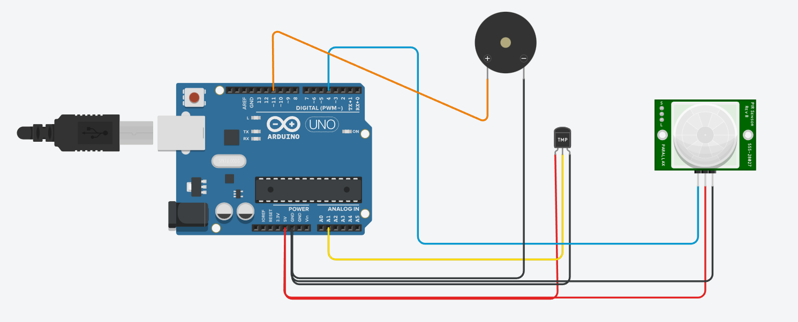

Motion Sensor :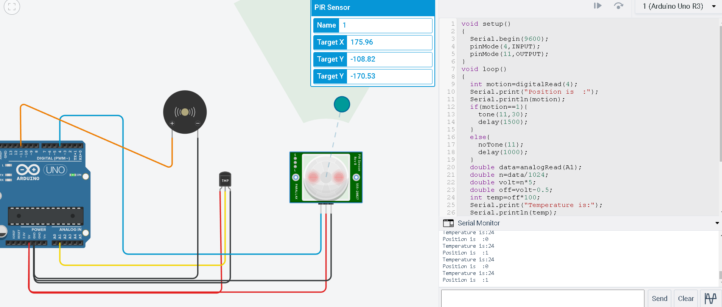Temperature Sensor:

